📊 Customer Shopping Behavior Analysis Report

1. Project Overview
This project aims to analyze customer shopping behavior to uncover patterns in purchasing, preferences, and engagement. The dashboard provides a visual summary of key metrics such as customer count, average purchase value, category performance, and demographic trends.
Objectives
- Understand customer purchasing patterns
- Identify top-performing product categories
- Analyze customer segments (age, gender, subscription status)
- Provide actionable business insights
Key KPIs
- Total Customers: 648
- Average Purchase Amount: $58.63
- Average Review Rating: 3.72

2. Dataset Summary
The dataset contains customer-level transactional and demographic data.
Key Features
- Customer ID – Unique identifier
- Gender – Male/Female
- Age Group – Young, Middle Age, Old
- Category – Clothing, Accessories, Footwear, Outerwear
- Purchase Amount – Transaction value
- Review Rating – Customer feedback score
- Subscription Status – Yes/No
- Shipping Type – Delivery preference
Data Characteristics
- Mixed categorical and numerical variables
- Moderate dataset size (648 records)
- Suitable for segmentation and behavioral analysis

3. Exploratory Data Analysis (Python)
Step 1: Data Loading & Inspection
import pandas as pd
df = pd.read_csv("shopping_data.csv")
df.head()
df.info()
df.describe()
Step 2: Data Cleaning
# Check missing values
df.isnull().sum()
# Handle missing values if any
df.dropna(inplace=True)
Step 3: Distribution Analysis
import matplotlib.pyplot as plt
import seaborn as sns
# Purchase distribution
sns.histplot(df['Purchase Amount'], kde=True)
plt.title("Purchase Amount Distribution")
plt.show()
Step 4: Category Analysis
category_sales = df.groupby('Category')['Purchase Amount'].sum()
category_sales.plot(kind='bar', title='Revenue by Category')
plt.show()
Step 5: Subscription Impact
sns.countplot(x='Subscription Status', data=df)
plt.title("Subscription Distribution")
plt.show()
Key EDA Insights
- Clothing generates the highest revenue
- Majority of customers are non-subscribers (~74%)
- Purchase amounts are moderately distributed
- Ratings suggest average customer satisfaction

4. Data Analysis Using SQL
Sample Queries & Insights
1. Revenue generated by male and female:
SELECT gender, sum(purchase_amount) AS revenue FROM customer group by gender;
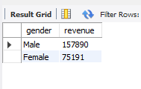
2. Top 5 prodcuts with the highest average review rating:
select item_purchased, round(avg(cast(review_rating as decimal(10,2))),2) as "Average product Rating" from customer
group by item_purchased
order by round(avg(cast(review_rating as decimal(10,2))),2) desc
limit 5;
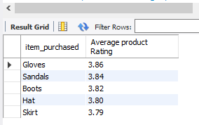
3. Average purchase amount b/w standard and express shipping:
select shipping_type,round(avg(purchase_amount),2)
from customer where shipping_type in ('standard','Express') group by shipping_type;
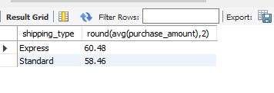
4. Top 5 products have the highest percentage of purchases with discount applied ?
use customer_behaviour;
select item_purchased,
Round(100 * sum(case when discount_applied = 'yes' then 1 else 0 end)/count(*),2) as discount_rate from customer
group by item_purchased
order by discount_rate desc
limit 5;
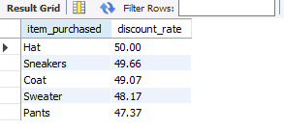
5. Top 3 most purchased products within each category:
with item_counts as (
select category,item_purchased,count(customer_id) as total_orders,
row_number() over (partition by category order by count(customer_id) desc
) as item_rank from customer
group by category,item_purchased
)
select item_rank,category,item_purchased,total_orders
from item_counts where item_rank <= 3;
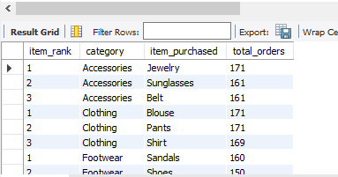

5. Key Findings
Customer Behavior
- A large portion (~74%) of customers are non-subscribers
- Subscription adoption is low but represents a growth opportunity
Category Performance
- Clothing is the top-performing category in both revenue and sales
- Outerwear has the lowest contribution
Demographics
- All age groups contribute similarly, indicating a broad target audience
- No extreme skew in age-based purchasing
Customer Satisfaction
- Average rating (3.72) suggests room for improvement

6. Business Recommendations
1. Increase Subscription Adoption
- Offer discounts or loyalty rewards
- Introduce exclusive member benefits
2. Focus on High-Performing Categories
- Expand Clothing & Accessories inventory
- Promote best-selling products
3. Improve Low-Performing Categories
- Optimize pricing or marketing for Outerwear
- Bundle with popular items
4. Enhance Customer Experience
- Address factors affecting ratings
- Improve product quality and delivery
5. Personalization Strategy
- Use customer segmentation for targeted campaigns
- Recommend products based on past purchases

7. Conclusion
The dashboard and analysis reveal strong performance in core categories and highlight opportunities in subscription growth and customer satisfaction improvement. By leveraging these insights, the business can optimize revenue and enhance customer engagement.

